**Module 3 (Testing on Live Application)**

**• What is RDBMS**

**RDBMS stands for relational database management system. It's a software system that lets users create, manage, and access data in a relational database. RDBMS is the foundation for many modern database systems, including Microsoft SQL Server, MySQL, Oracle, and Microsoft Access.**

**• What is SQL**

**SQL is Structured Query Language, which is a computer language for storing, manipulating and retrieving data stored in relational database. SQL is the standard language for Relation Database System. All relational database management systems like MySQL, MS Access, Oracle, Sybase, Informix, postgres and SQL Server use SQL as standard database language.**

**• Write SQL Commands**

**⚫ DDL – Data Definition Language**

**⚫ DML – Data Manipulation Language**

**⚫ DCL – Data Control Language**

**⚫ DQL – Data Query Language**

**• What is join?**

**In SQL, a "JOIN" is a command that combines rows from two or more tables based on a related column, allowing you to retrieve data from multiple tables in a single query.**

**• Write type of joins.**

**SQL Join Types**

**⚫ INNER JOIN**: **returns rows when there is a match in both tables.**

**⚫ LEFT JOIN: returns all rows from the left table, even if there are no matches in the right table.**

**⚫ RIGHT JOIN: returns all rows from the right table, even if there are no matches in the left table.**

**⚫ FULL JOIN: returns rows when there is a match in one of the tables.**

**• How Many constraint and describes it self**

* [**NOT NULL**](https://www.w3schools.com/sql/sql_notnull.asp)**- Ensures that a column cannot have a NULL value**
* [**UNIQUE**](https://www.w3schools.com/sql/sql_unique.asp)**- Ensures that all values in a column are different**
* [**PRIMARY KEY**](https://www.w3schools.com/sql/sql_primarykey.asp)**- A combination of a NOT NULL and UNIQUE. Uniquely identifies each row in a table**
* [**FOREIGN KEY**](https://www.w3schools.com/sql/sql_foreignkey.asp)**- Prevents actions that would destroy links between tables**
* [**CHECK**](https://www.w3schools.com/sql/sql_check.asp)**- Ensures that the values in a column satisfies a specific condition**
* [**DEFAULT**](https://www.w3schools.com/sql/sql_default.asp)**- Sets a default value for a column if no value is specified**
* [**CREATE INDEX**](https://www.w3schools.com/sql/sql_create_index.asp)**- Used to create and retrieve data from the database very quickly.**

**• Difference between RDBMS vs DBMS**

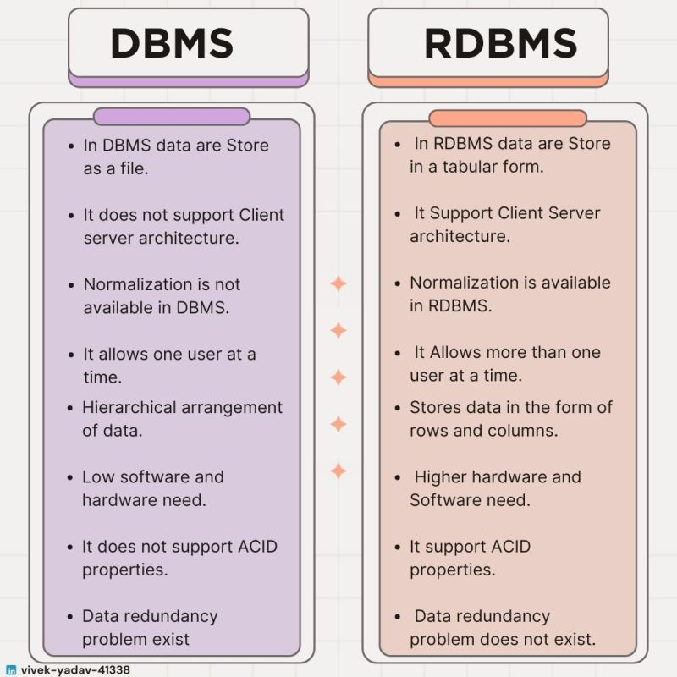

**• What is API Testing**

**Application Programming Interface (API) is a software interface that allows two applications to interact with each other without any user intervention another definition , API (Application Programming Interface) is a computing interface which enables communication and data exchange between two separate software systems.**

**• Types of API Testing**

**There are mainly 3 types of API Testing**

**⚫ Open APIs: These types of APIs are publicly available to use like OAuth APIs from Google. It has also not given any restriction to use them. So, they are also known as Public APIs.**

**⚫ Partner APIs: Specific rights or licenses to access this type of API because they are not available to the public.**

**⚫ Internal APIs: Internal or private. These APIs are developed by companies to use in their internal systems. It helps you to enhance the productivity of your teams.**

**• What is Responsive Testing?**

**Responsive testing verifies how a website or web application functions and appears across various devices, screen sizes, and resolutions, ensuring a seamless user experience. This involves checking if the website's layout, images, text, and interactive elements adapt effectively to different devices and screen sizes, including desktops, laptops, tablets, and smartphones**.

**• Which types of tools are available for Responsive Testing**

**→ LT Browser**

**→ Lembda Testing**

**→ Google**

**→ am responsive**

**→ Pixel tune**

**• What is the full form of .ipa, .apk**

**The full form of .ipa is iOS App Store Package, and the full form of .apk is Android Package Kit or Android Application Package.**

**• How to create step for to open the developer option mode ON?**

**To enable developer options on an Android device,**

**navigate to Settings > About phone > Build number and tap the build number seven times.**

• **To check**